Negative Numbers Worksheet

Start in the outer ring and read inwards to make a sum. Fill in the gaps.
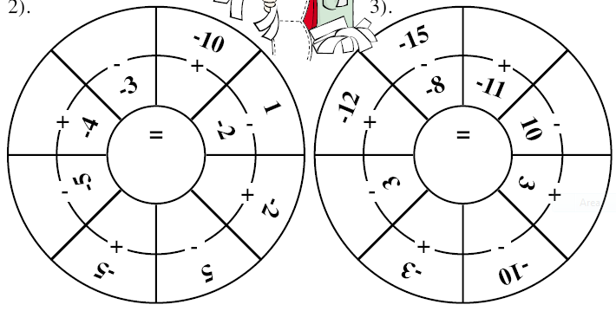

Fill in the gaps in this multiplication table.
x |  | -1 |  |  | 2
2 |  |  |  | -8
 | -2 | 2 |  |  | -4
-3 |  |  | -9

To find the next number, multiply the two bricks below it. You might need to use a long multiplication method, but NO CALCULATOR!
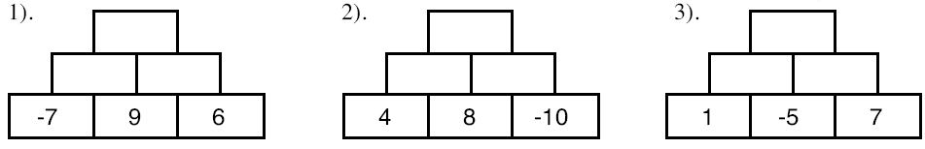
-3
-1
4
4)
5)
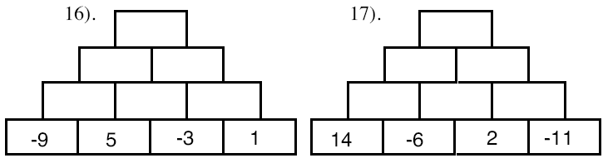
-4
-3
6)
7)
8)
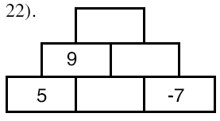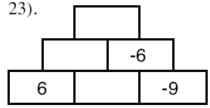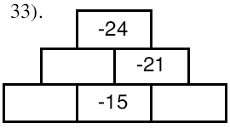
-15
18
-48
-8
2

